Problem 1:
- Suppose that if we remove line 6-8 in STRAIGHTEN and WEIRDSORT still correctly sort.
This contradiction statement therefore means there exist no array that has elements of power of 2 cannot be sort by the WERIDSORT with line 6-8 in STRAIGHTEN removed.
Thus, there exist integer array with n elements, where n is a power of 2.
Taking the array, A = [4,3,2,1] as a counter example where n =4. First WEIRDSORT(A[1…4]), n>0 therefore we execute WEIRDSORT(A[1..2]) in line 2. WEIRDSORT[A[1..2]], execute WEIRDSORT(A[1..1]), which n =1 and as stated in line 1, it did not do anything but return to line 3 in WEIRDSORT(A[1..2]), which also return right away without doing anything. So going straight to line 4 in WEIRDSORT(A[1..2]), which executes STRAIGHTEN(A[1..2]). Here at the base case in line 1, and A[2]=3 < A[1]=4(line2), then swap A[1] and A[2] which then change A[1..2] to [3,4] and then return to the upper level of WEIRDSORT[A[1..4]] and then execute line 3 WEIRDSORT(A[3..4]). The same thing happens for WEIRDSORT(A[3..4]) which changes A[3..4] to [1,2] and return to the upper level.
Then line4 was executed, STRAIGHTEN[A[1..4]], right now A =[3,4,1,2] where n =4. Since n is not 2 and line 6-8 is removed. Line 9 is executed, STRAIGHTEN(A[1..2]) and base case return A[1..2] = [3,4]. Then STRAIGHTEN(A[3..4]), return A[3..4] = [1,2]. So after line 10, A[1..4] = [3,4,1,2]. Then STRAIGHTEN[A[2,3]], results in A[1..4] = [3,1,4,2]. And the final result of the sorting process does not match with the correct result which should be A=[1,2,3,4].
But all the logic after the first line of the proof is correct, so it must be that the first line was incorrect. In other words, we were wrong to assume the proposition was true. Thus the proposition is false.

- Suppose that if we swap line 10 & 11 in STRAIGHTEN and WEIRDSORT still correctly sort.
This contradiction statement therefore means there exist no array that has elements of power of 2 cannot be sort by the WERIDSORT with line 10 & 11 in STRAIGHTEN swapped.
Thus, there exist integer array with n elements, where n is a power of 2.
Taking A=[4,3,2,1] as the example. Everything was the same as discussed in question 1 up till line 4 in WEIRDSORT[1..4]. Before entering STRAIGHTEN[1..4], A=[3,4,1,2]. Since n is not equal to 2, else in line 5 is executed. Line 6 -8, result in A=[3,1,4,2]. Then line 9 would call the base case on A[1..2], which change A to [1,3,4,2]. And since line 11 and 10 was swapped. Execute line 11 would call the base case on A[2..3], which is already in order. And the line 10 was called, STRAIGHTEN[A[3..4]] would change A to [1,3,2,4]. And the final result of the sorting process does not match with the correct result which should be A=[1,2,3,4].
But all the logic after the first line of the proof is correct, so it must be that the first line was incorrect. In other words, we were wrong to assume the proposition was true. Thus the proposition is false.
- Claim 1: For any array A with n= elements and both A[0..] and A[..n] are sorted, STRAIGHTEN could correctly return a merged sorted array.
Proof: Let n = denotes the number of elements in the input array.
- Base case: n=2. STRAIGHTEN(A[1..k]) would run line 1-4 in STRAIGHTEN. It would compare the two elements in A and then swap if A[2] < A[1]. And then STRAIGHTEN(A[1..2]) would return a array with correctly sorted elements.
- Induction Hypothesis: P(k):Assume that STRAIGHTEN could correctly return the sorted array for n = numbers of element.
- Induction Step: Now need to show STRAIGHTEN also works for m = 2n = numbers of element. Assuming we have a array of A[1..m] which is just A[1..2n]. Before Entering STRAIGHTEN([1..m]), WERITDSORT([1..m]) first called WEIRDSORT(A[1..]) and WEIRTSORT(A[..m]), which all calls STREIGHTEN[A[1..n]] with n numbers of element. By the induction hypothesis, A[1..] and A[..m]is already sorted in ascending order.
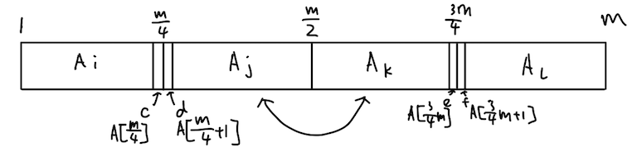
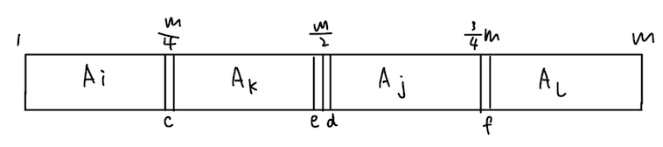
Now we have the array before STRAIGHTEN starts to recursive call. Let A[1..] be A_{i}, A[+1..] be A_{j}, A[] be A_{k} and A[] A_{l}. Let the biggest number in A_{i} be c, the smallest number in A_{j} be d, the biggest number in A_{k} be e and the smallest number in A_{l} be f. According to line 6-8, A_{j} and A_{k} is swapped. So now A is in order A_{i}, A_{k} , A_{j} and A_{l}.
And then Line 9, STRAIGHTEN(A[1..]) and line 10 STRAITHTEN(A[..m]). By the induction Hypothesis, STRAIGHTEN(A[1..n]) for 2^{k} elements correctly return the sorted input array. Therefore, line 9 and line 10 sort A[1..]) and A[..m] correctly. Now, we have a new different sorted array. Let A[1..] be B_{i}, A[+1..] be B_{j}, A[] be B_{k} and A[] B_{l}.
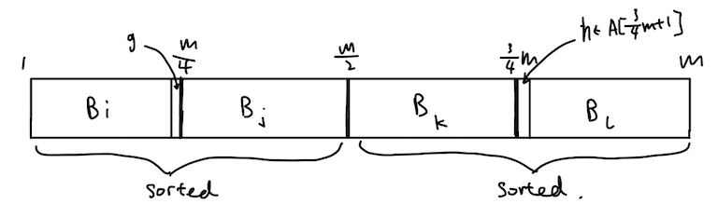
So, the biggest number in B_{i} at index A[] is g. And we know c is larger than any element in A_{i}, and e is larger than any element in A_{k}. Because c and g was the biggest element in its own part, after combing and resorted A[1..],the smaller one of c and e would still be larger than g. As we already know A[1..] is sorted, every element in B_{j} is larger element in B_{i}. The smallest number in the A[] is either the d or f, since the smallest number of two combined arrays is the smallest of one of the arrays. Because c or e is no less than g, d is bigger than c, f is bigger than e, either the smaller one in d or f is going to be larger than c or e a, and larger than g. Since A[..m] is sorted, every element in B_{k} is smaller than element in B_{l} . Therefore, we know both B_{k} and B_{l} is larger than B_{i}. Therefore, B_{i} is the smallest of A[1..m]. And B_{i} is already in the right place.
The same thing goes for B_{l}. So the smallest element of B_{l} at index A[] name it h. As we know, either of the d and f is not bigger than h. The biggest of B_{i} and B_{j} is either the biggest of A_{i} and A_{k}, which means at A[] it is either going to be c or e. And c <d, e<f, so A[] is smaller than h. Therefore, every element in A_{i} and A_{k} is smaller than elements in B_{l}. And since A[..m] is sorted, every element in B_{k} is smaller than element in B_{l.} So, elements in B_{l} is bigger than all other elements and sorted, which means it's in the right place.
Therefore, B_{i} and B_{k} is already correctly sorted.
And then the sort calls on A[], which by the Induction hypothesis, return the correct result of a sorted array.
Since B_{i} and B_{k} are in the right place and A[] give the correct result, A[1..m] is a correctly sorted array. Therefore by induction, For any array A with k= elements, STRAIGHTEN could correctly return a merged sorted array

Claim 2: For any array A with n = elements, WEIRDSORT would correctly sort A.
Proof:
- Base case: There are 2 elements in array A. WEIRDSORT(A[1..2]) would call line3, line4 WEIRDSORT with 1 element and would return right away. And STRAIGHTEN as show above, would return the correct sorted array. And Base case is true.
- Induction Hypothesis: S(k): Assume there is n = 2^{k} elements in the array A, WEIRDSORT could correctly return the correct output.
- Induction Step: Need to prove S(k+1) also holds, which means there is m = 2n = 2^{k+1} elements. As the induction hypothesis suggest, line2 and line3 will return the correct sorted array. And as we show above, STRAIGHTEN could correctly merge them into one sorted array with element m. Therefore S(k+1) holds. For any array A with n = elements, WEIRDSORT would correctly sort A.

- Number of comparison made by STRAIGHTEN on array of size n:
S(n) =
Number of comparison =

Number of comparison made by WEIRDSORT on array of size n:
T(n) = 2 T() + let = x
= 2 (2T() + x) + x
= 2^{k} T() + ()x
= 2^{k} T() + (1-)
T(2) = 1 T(n) = -n
Number of comparison = -n
O(n) = O(n^{1.585})

